
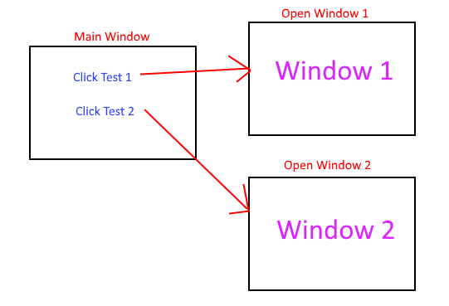
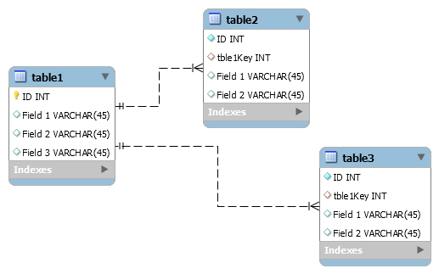
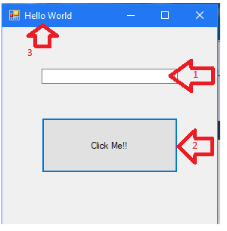

JG Software Corporation
Customer Report Mgr.
Performance Assessment: Software Engineering - NUP1
Jeremy Greenwood
October 9, 2019
Version 1.0

Contents
A.Introduction 3
A.1. PUrpose Statement 3
A.2. Overview of THE PROBLEM 3
A.3. Goals and Objectives 3
A.4. Prerequisites 3
A.5. Scope 3
A.6. Environment 3
B.Requirements 4
B.1. Business Requirements 4
B.2. User Requirements 4
B.3. Functional Requirements 4
B.4. NonFunctional Requirements 4
C.SOFTWARE DEVELOPMENT METHODOLOGY 5
C.1. Advantages of the waterfall method 5
C.2. disAdvantages of the waterfall method 5
C.3. Advantages of {A DIFFERENT METHOD} 5
C.4. disAdvantages of {A DIFFERENT method} 5
C.5. best SUITED 5
D.Design 6
D.1. Storyboard or Flowchart (Change title to fit needs) 6
D.2. UML Diagram (Change title to fit needs) 7
D.3. GUI (Change title to fit needs) 8
E.Testing 9
E.1. Testing Type (change name to fit your needs) 9
E.1.1. Test Name 1 9
E.1.2. Test Name 2 10
E.1.3. Test Name 3 11
F.Sources 13

Introduction
Business thrives on customers. They are the life blood of any successful enterprise. In order for a company to grow, it must find and attract more clients all the while retaining its current roster of patrons. As the number of customer relationships grows, a system must be put in place to manage those relationships. That is where a Customer Relationship Management System comes in, keeping track of details, preferences, and history in order to leverage data for future prospects and sales.

A.1. PUrpose Statement
This document serves to clearly define JG SoftwareCorp's (JGSC) proposal to meet American Video Game Company's (AVGC) needs for a Customer Relationship Management System (CRM). It will compare and contrast software development methodologies to be used, provide visual representation of the system prototype, as well as detail testing processes and features.

A.2. Overview of THE PROBLEM
Currently, AVGC is growing at an enviable pace. Sales are up by 42% over the past two years. AVGC is poised to continue steady growth, expand into new areas, and capitalize on secondary revenue streams. Unfortunately, this growth means AVGC is rapidly outpacing the abilities of its current amalgam of CRM solutions. At present, AVGC is utilizing a mixture of highly customized spreadsheet and database management products with manual processes, spread across multiple offices and remote locations. In addition to being unwieldy, this has the potential to duplicate work as well as allow sales and growth opportunities to fall through the cracks.
JGSC's proposed solution will present AVGC with a CRM solution that focuses on:
- managing client contact information
- tracking sales data
- regulating activity management
- overseeing reporting
- configuring and controlling access to system features

A.3. Goals and Objectives
Upon completion, JG SoftwareCorp's proposed CRM solution will provide the means to:
- merge contact and business information into one point of access
- track and analyze current and past sales data
- regulate day-to-day activities
- gain up-to-the-minute access to company activities and interactions with contacts

In addition, our software solution will:
- provide robust security features, standard throughout the industry
- provide configurable access to functionality and utility for the company's internal and remote users
- provide regulated system access for contracted 3rd parties
- maintain compatibility with AVGC's internal systems, allowing seamless integration for sharing data
- offer the potential for future enhancement and scalability

Lastly, like all JGSC products, our CRM features:
- Simple, easy-to-operate User Interface with a stellar User Experience
- World-class support and a surprisingly affordable maintenance program
- Regular (optional) updates with a development plan published quarterly
- User customizable feature-sets that can be extended, modified, and integrated without relying on JGSC or 3rd parties

A.4. Prerequisites
Number | Prerequisite | Description | Completion Date
1 | System Analysis | In order to get an accurate depiction of the currently used CRM, JGSC needs unfettered access to the network and networking facilities for the period of 2 weeks to monitor typical usage and to understand exactly what will be involved in migrating existing subsystems to JGSC's CRM. | 11/01/19
2 | Network | The JGSC CRM is entirely web based. As such, a broadband internet connection is required. Bandwidth to support 500 concurrent users, with expandable capacity for up to 2000 is estimated at a minimum of 100Mbps download and 20Mbps upload. | 11/15/19
3 | Servers | Processing power to service operations for 500 concurrent users, with expandable capacity of up to 2000. | 11/20/19

A.5. Scope
The JGSC CRM solution provides the ability to manage, configure, and process customer contacts on an enterprise scale. It does not provide physical access to those contacts. That is achieved by AVGC's own hardware, running software designed by JGSC specifically for AVGC. While JGSC will strive to meet all of AVGC's CRM needs, all concerns regarding uptime and availability will be limited by AVGC's own resources and management plan. Appropriate staffing of JGSC support personnel and AVGC equipment configuration will be governed by Service Level Agreements (SLA) between both entities. This will include regular maintenance and updates for the length of the contract as well as limited emergency support subject to the SLA.

A.6. Environment

The JGSC CRM solution is a web-based software package. It will be hosted on AVGC's existing network infrastructure to provide maximum accessibility with minimum response time when the unforeseen does occur. This will also allow AVGC to expand as it needs while still managing to control costs. In addition, this will ensure that AVGC maintains sole control of the data, thusly being able to limit its access in the US and abroad.
Our current CRM offering supports all HTML5 compliant browsers, including current versions of Chrome/Chromium, Firefox, Safari, and Internet Explorer on desktop and mobile OSes. The data is maintained using PostgreSQL and rendered server-side with Node.js. This allows every query to be tailored specifically to that users needs, locale, and access privileges. In addition, the open-source nature of these tools allows JGSC to build and customize whatever additional solutions AVGC may need in the future, who then retains said tools for development and use as AVGC sees fit.
Our entire CRM solution is coded using HTML5, CSS, SQL, and JavaScript (ES6).

Requirements
Enterprise environments present a number of technical challenges due to their size and complexity. This CRM solution proposal focuses on 5 of those challenges which appear in AVGC's requirements. It will address contact management, ticketing, sales activity management, sales quoting, and delivering predefined and custom reports.

Business Requirements
As part of contact management, JGSC's CRM solution utilizes a role-based contact system. Every user is categorized by their hierarchical identity within the user matrix. That identity grants the user access to their own profile entry, limits their access to other entries within the CRM system, and dictates which set of terms and conditions constrains the user's information. This allows those with contact roles to be assigned privileges to directly manage their own profile, without the fear of accidentally or maliciously modifying another contact's profile. Conversely, AVGC's personnel roles are granted privileges to modify contact profiles associated with their accounts.

User Requirements
Information auditing is imbedded within JGSC's event-oriented ticketing system. A contact event generates a ticket with any email, text messaging, or telephone system instance. The system then maps the information from the communication (in accordance with local laws and access privileges) to the CRM solution's database. The AVGC user will no longer be required to manually log or enter details about the customer contact. This will occur automatically as a course of normal interaction.
Sales quoting is automatically tracked through contact events which are filtered through proprietary algorithms that identify the customer's stated needs. A quote is generated and provided to the AVGC representative and respective customer. The quote is verified by all parties and passed through the activity management filter. This generates an audit trail AVGC and helps to ensure all requested customer interactions are handled. This frees the AVGC representative to focus on the needs of the customer without getting bogged down in the minutiae of the sales catalog or day-to-day record keeping.

Functional Requirements
Detailed reports can be generated through the JGSC's report menu. A selection of standard reports can be generated as well as customized reports ready for filtering, formatting, and export. The system will sort through the appropriately privileged database entries and return matching entries. Report query settings can be saved for reuse and shared between users without sharing the specific report or underlying data.

NonFunctional Requirements
Information security is integrated at every step within the JGSC CRM solution. User roles limit data access. As an example, information deletion access is specifically limited. All deletions are “soft delete” by default. The information will be hidden from the user, but remain in the database for 30 days or until someone with “hard delete” privileges removes the information permanently.
In addition, every time a contact's information is accessed, a system log is generated in further efforts to protect their data.

SOFTWARE DEVELOPMENT METHODOLOGY
This project will be developed following the waterfall method. This method is a sequence of stages where each must be completed before the next may begin. The results of each stage are used to perform the tasks for the next stage. As the requirements submitted to JGSC are very clearly defined and relatively standardized to industry expectations, they lend themselves to the waterfall method.
C.1 Advantages of waterfall | C.2 disAdvantages of waterfall
- Phases are clearly delineated, thus scheduling can be readily controlled  - Requirements are clearly defined before design begins, preventing scope creep.  - Product provides full functionality and utility at deployment, minimizing downtime for transition. | - Changes in specification create burdensome delays. Unexpected hurdles create significant delays.  - Phasing in the product gradually is not an option as it can not be deployed until all components are completed.
C.3 Advantages of SPIRAL | C.4 DisAdvantages of SPIRAL
- As a result of its spiraling nature, stakeholders have multiple points for review  - Changes in specification and design are readily accommodated  - Time and cost estimates as well as risk analysis become more accurate as the task progresses | - Its complexity increases risk of delay and cost overrun  - Since requirements are so clearly defined, the increasing accuracy of time and cost benefits as the project progresses will never be realized

C.5 best SUITED
Of the two choices, the waterfall methodology is the better selection. The project requirements are very clearly noted in the project specifications. As such, design changes and scope creep will be minimal. Additionally, as mentioned above, the increased accuracy of time and cost benefits in the Spiral Method would not be likely to materialize. Most importantly, while the initial time to design, develop, and implement the CRM solution is significant, AVGC is not under serious time constraints. As such, the JGSC can build a solution tailored to AVGC's specific needs and minimize time lost to transition by ensuring the solution is complete before rollout.

Design
JGSC strives to keep designs intuitive. Our goal is for technology to reduce the number of tasks employees are required to execute. The following Ticket Storyboard indicates how seamlessly the process works once the user initiates contact.

D.1. Ticket Storyboard
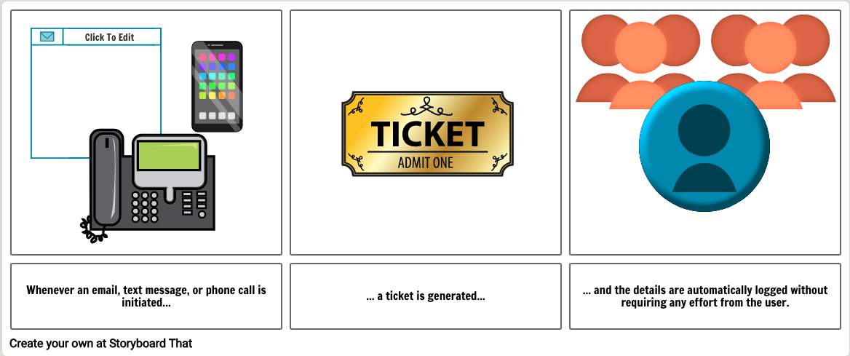
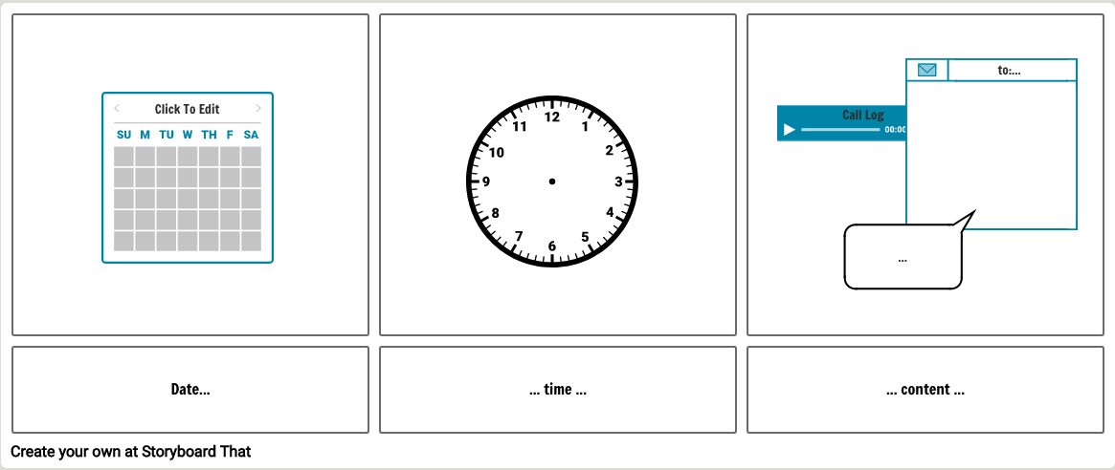
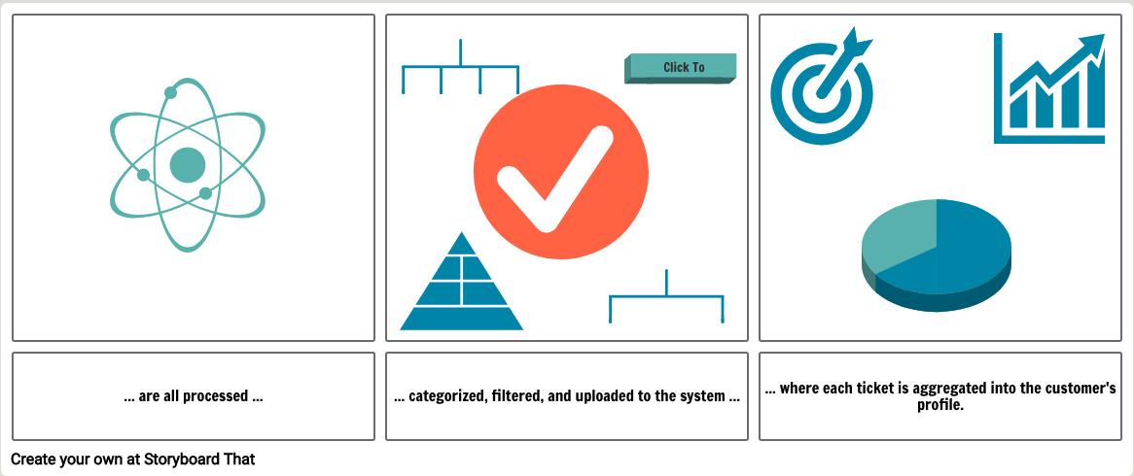

D.2. REPORTS GUI
The Reports menu allows standard reports to be generated as well as custom reports via the filtering and formatting menus.
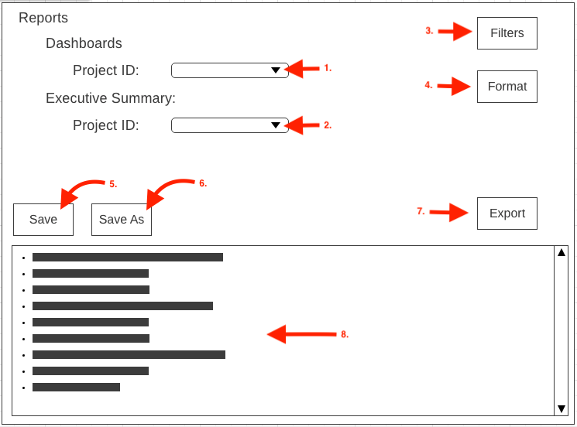
GUI Control Mapping
ID | Control | Property |  | Data Source
1 | ComboBox | On application open text = “” or null |  | NA
1 | ComboBox | On click query DB for ID and render to ListView |  | DB variable
2 | ComboBox | On application open text = “” or null |  | NA
2 | ComboBox | On click query DB for ID and render to ListView |  | DB variable
3 | Button | On click load filters menu |  | NA
4 | Button | On click load format menu |  | NA
5 | Button | On click open save menu |  | NA
6 | Button | On click open save-as menu |  | NA
7 | Button | On click open export menu |  | NA
8 | ListView | Display preview data |  | DB query result

Testing
Every aspect of the CRM solution will be tested extensively. This section lists 3 aspects of the system and gives a brief overview of their testing methodology: import efficiency, report formatting,

E.1. Testing Type: Grey BOX
The goal of this testing segment is to ensure that Activity Management data is accessed safely and rendered efficiently. The testing team will have some knowledge of the process internals. They will utilize grey box methodology to take advantage of that fact.

E.1.1. Test 1: Import
Requirement to be tested
Test efficiency of DB data import, including validation and minimizing risk.
Preconditions:
System has active, secure connections to system, network, and database.
Intermediate cache is current.
User permissions are valid.
Steps:
- Form query and submit.
- System returns preliminary results from cache.
- While user is viewing preliminary results, system forwards query to DB queue.
- Update results with DB response.

Expected results: Expected results and any side effects such as updating a database, writing to a file, etc.
If the system performs efficiently, preliminary results will be rendered and supported with full DB. There should be no side effects and data is being READ only. The use of the intermediate cache should reduce perceived access times to target values.
Pass/Fail: Mark whether the test case passed or failed. The results can be compiled and used to determine if the application is ready for delivery/release.
PASS:
- preliminary results are rendered in under 500ms
- secondary results supplant preliminary results in under 3500ms
- no side effects are determined
- test is successfully repeated 10 consecutive times for 10 different users

E.1.2. Test 2: Report format
Requirement to be tested
Test formatting of automatically generated dashboards.
Preconditions:
Reports screen is displayed.
Project ID is valid.
Project data associated with ID is valid.
User has valid privileges for Project data access.
Steps:
- Click “ProjectID” ComboBox.
- Click a string in ComboBox.
- Observe data rendered in ListView.
- Verify data shown is rendered to the appropriate row.
- Verify data shown is rendered to the appropriate column.
Expected results: Expected results and any side effects such as updating a database, writing to a file, etc.
If rendered correctly, data will be retrieved from the DB using the predefined query. That data will be parsed correctly and the display will match expected formatting guidelines. No side effects generated as this is a READ only operation.
Pass/Fail: Mark whether the test case passed or failed. The results can be compiled and used to determine if the application is ready for delivery/release.
PASS:
- Data in columns and rows match DB entries.
- Format adheres to pre-established guidelines.
- Verify no side effects as a result of operation.

E.1.3. Test 3: user validation
Requirement to be tested
User is granted access to data relevant to the user's department or function.

Preconditions: Conditions that must be present before test case can successfully run
Login screen is visible.
Steps: The steps the tester must execute to test the feature.
- Access the Login screen.
- Enter username in “User:” field.
- Enter password in “Password:” field
- Click the “Login” button OR
Press the “Enter” key when the “Password:” field or “Login” button has focus.
- Continue to User screen.
- Access data.
Expected results: Expected results and any side effects such as updating a database, writing to a file, etc.
Upon entering a username & password combination, the system will submit the entry to the login validation function. The login validation function will determine credential validity and assign user appropriate privileges as they are delegated within the user database. System will log successful entry into the log history.

Pass/Fail: Mark whether the test case passed or failed. The results can be compiled and used to determine if the application is ready for delivery/release.
PASS:
- Incorrect login information causes login task to fail.
- Correct login information causes login task to pass.
- Correct login information limits access to only data associated with the user's role.

Sources
Place the sources that you used here.
N/A

